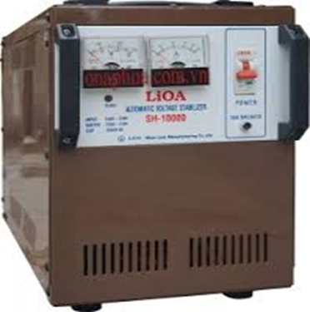

Automatic voltage stabilizer 1 phase

Product Code: SH - DRI
Description
- Principle adjust engine power to help stabilize the continuous line
- Three times safety is protected 3 in 1:
- Overvoltage protection,
- overload protection,
- switching power on.
- Industrial Designs
- Quality is confirmed in the last decade
- Smooth running, low power self-help device power capacity in order to
- romote the best use features, durable equipment and power savings.
- Overload protection CB
- Overvoltage protection CB input
