Automatic voltage stabilizer 3 phase dry type

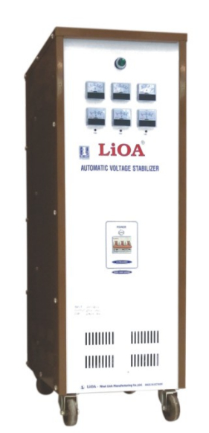
Product Code SH3
Description
Adjust independent third phase should fit all the harsh grid
CB Overload protection
CB Overload protection at input
